3.9 Exercises 179

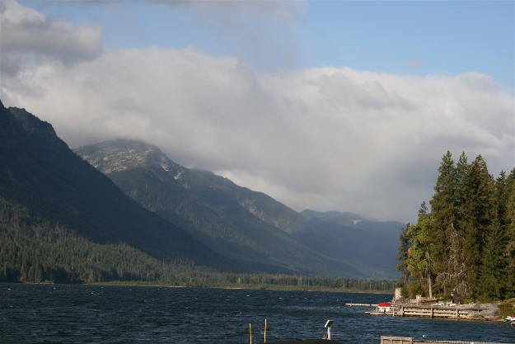

**Figure 3.66** There is a faint image of a rainbow visible in the right hand side of this picture. Can you think of a way to enhance it (Exercise 3.29)?

1. Fit an *additive* rainbow function (explain why it is additive) to this arc (it is best to work with linearized pixel values), using the spectrum as the cross section, and estimating the width of the arc and the amount of color being added. This is the trickiest part of the problem, as you need to tease apart the (low-frequency) rainbow pattern and the natural image hiding behind it.
2. Amplify the rainbow signal and add it back into the image, re-applying the gamma function if necessary to produce the ﬁnal image.

**Ex 3.30: Image deblocking—challenging** Now that you have some good techniques to distinguish signal from noise, develop a technique to remove the *blocking artifacts* that occur with JPEG at high compression settings (Section 2.3.3). Your technique can be as simple as looking for unexpected edges along block boundaries, to looking at the quantization step as a projection of a convex region of the transform coefﬁcient space onto the corresponding quantized values.

1. Does the knowledge of the compression factor, which is available in the JPEG header information, help you perform better deblocking?
2. Because the quantization occurs in the DCT transformed YCbCr space (2.115), it may be preferable to perform the analysis in this space. On the other hand, image priors make more sense in an RGB space (or do they?). Decide how you will approach this dichotomy and discuss your choice.
3. While you are at it, since the YCbCr conversion is followed by a chrominance subsam- pling stage (before the DCT), see if you can restore some of the lost high-frequency chrominance signal using one of the better restoration techniques discussed in this chapter.
4. If your camera has a RAW + JPEG mode, how close can you come to the noise-free true pixel values? (This suggestion may not be that useful, since cameras generally use reasonably high quality settings for their RAW + JPEG models.)